Vancouver Island Minor Lacrosse Commission
Regular Meeting Minutes
March 2, 2026

Attendees
Voting Executive
Chair Andy Stuart
Vice Chair Scott Barillaro
Secretary Krista Gregory
Treasurer Michelle Vecqueray
Zone 6 Representative Adam Gow
Web Master/Scheduler Liaison Jeremy Penzin
Female Coordinator Kate Blass

VIMLC Executive
BCLOA Representative Sarah Dmytruk (absent)
Indigenous Development Bryan Baxter
BCLCA Representative Kelly Fines

Association Representatives
Alberni Valley Jeremy Penzin
Campbell River Sarah Thomas
Comox Valley Chad Robinson
Cowichan Valley Kim Solecki
Juan de Fuca Kyla Pedlow, Nikila Cyr
Nanaimo Bryan Norby, Cathy Coulson
Oceanside Ryan Minty
Peninsula Rod Senior, Simon Upshon
Saanich Scott Barillaro, Katherine Dyrland, Doug Anderson
Victoria Esquimalt Kate Blass, Stacey Santos, Bryce Taylor

Other Attendees Greg Toll

- Call Meeting to Order 7:01 pm
Land Acknowledgement

- Adoption of Previous Minutes
Motion to accept Minutes as circulated made by Ryan Minty, seconded by Scott Barillaro, Carried

- Additions and Adoption of Agenda
Motion to accept Agenda as circulated made by Kate Blass, seconded by Rod Senior, Carried

- Business Arising from the Minutes
none

- Financial Report: Michelle Vecqueray

Current Bank balance is $21,143.69.
There are no outstanding bank items.
Attached is the Budget vs Actual statement as of February 2026 as well as the February Bank Reconciliation.
I will be sending invoices out to associations mid March for the first half of the VIMLC Dues.
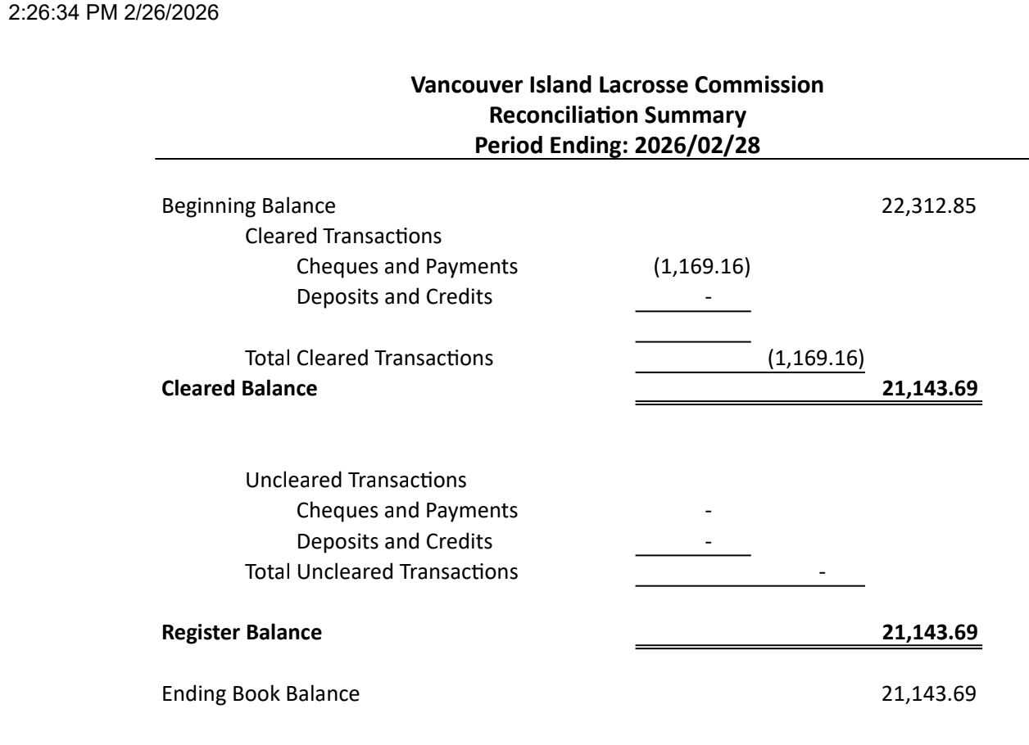

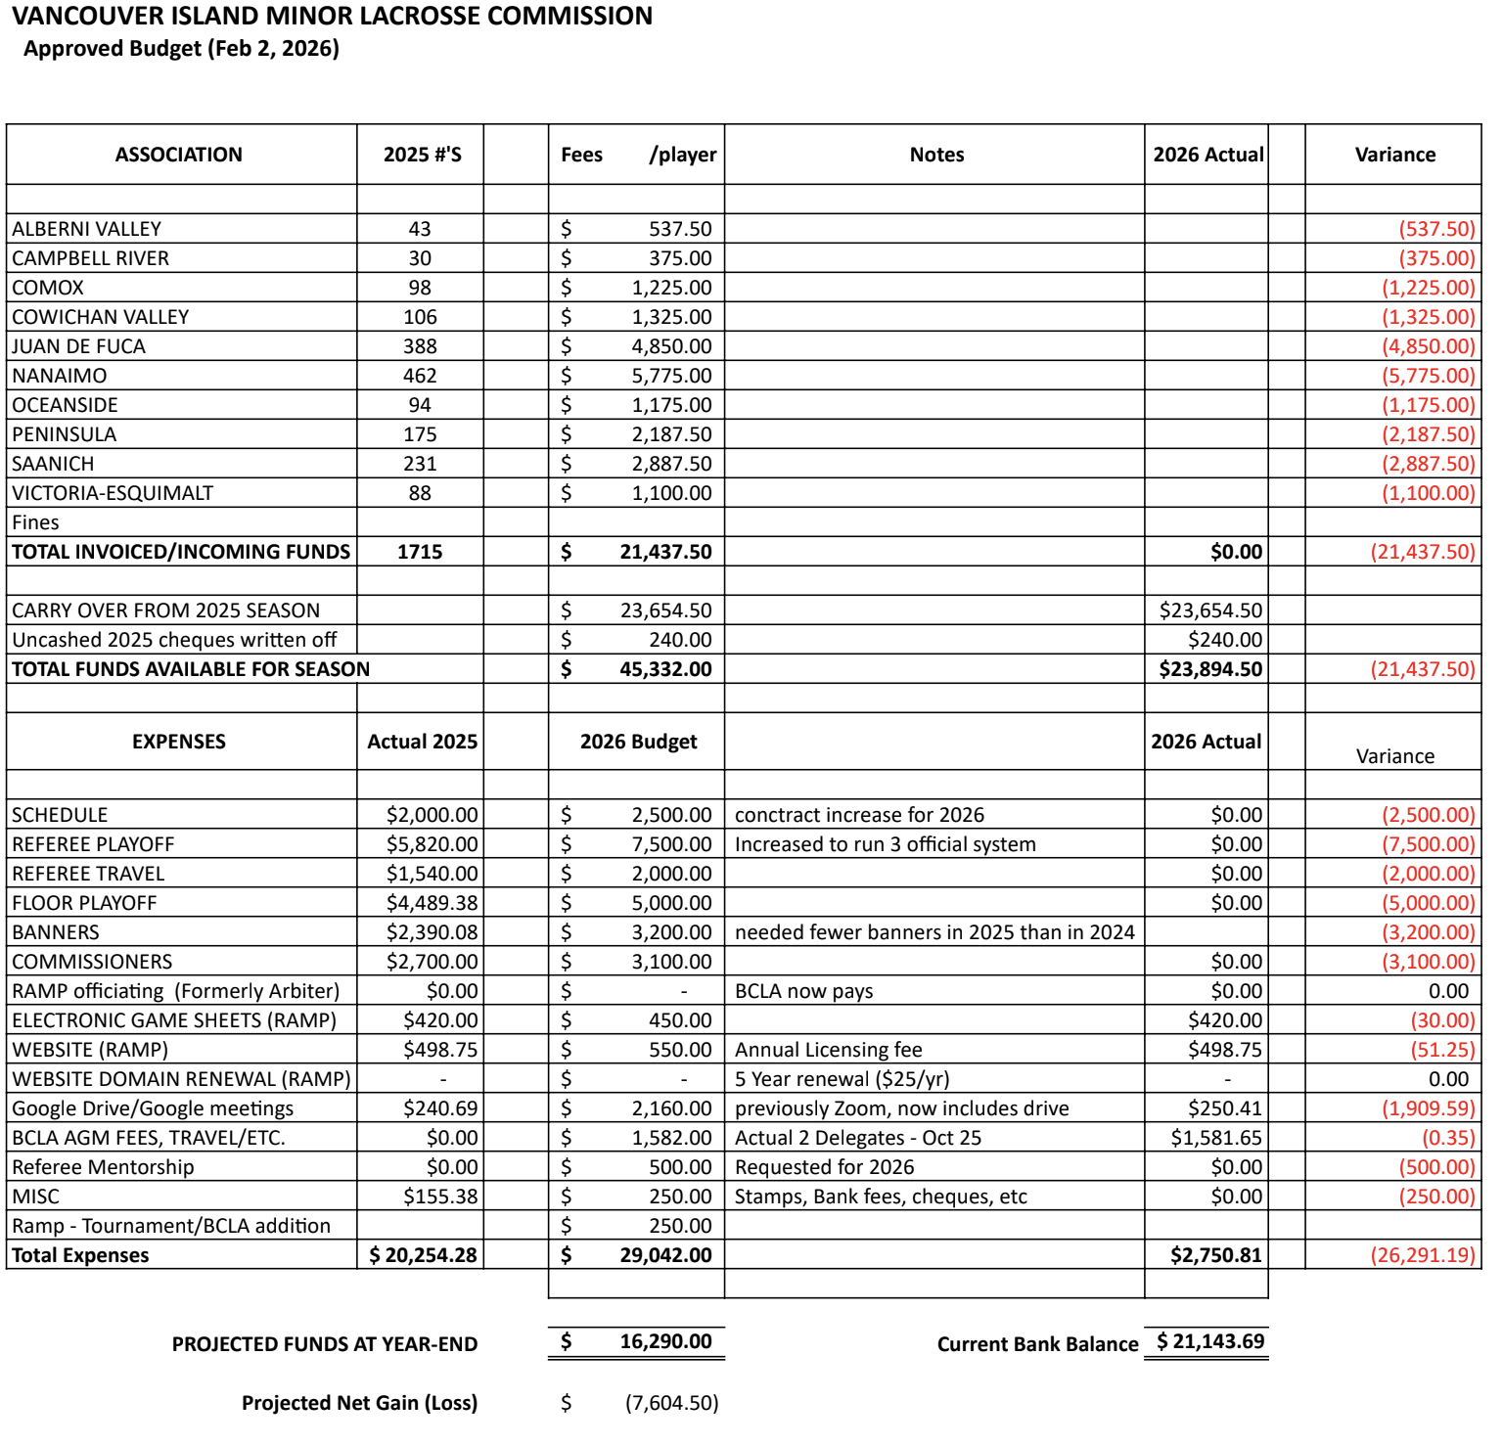

- Zone 6 Reports
- Chair Andy Stuart
We are working with Kelly Fines and Bryan Baxter to set up coaching clinics on the Island.
The schedule will have fewer games for U15 and U17 A teams against each other to leave room for exhibition games against Lower Mainland teams.
The LMMLC has requested that tournament coordinators use the MyLax naming conventions for visiting teams, so that their tournament results can be used in the MyLax calculations.

- Minor Directorate Rep Adam Gow
The MD met in February to go over the new rule exceptions. All presidents should have received a spreadsheet copy of the specific rules which BCLA will not follow per age group. The remainder of the new rules will be followed. The biggest exception is the larger nets will not be used within BC this season, any interprovincial play or Nationals will be using all new rules and nets.
Commissioners have all been appointed and should receive their VIMLC email access soon. There will be a ratification vote March 12 at the MD and a commissioner zoom meeting March 26.
The MD has asked the question if any associations have put thought into U5. I think this might be a little busy of a time for anyone to actually consider yet. I believe there is interest for the MD to petition the BCLA to cover in bylaws and policies.
Otherwise not much to report as we only held the special rule exception meeting this month.

- Vice Chair Scott Barillaro
Significant work on schedule development has occurred behind the scenes since last month. Floor allocators met with Jenn and I to discuss approach and information requirements. We've received floor times from most associations. We hope to collect a few outstanding items this week. Jenn has started mocking up the schedule based on what she has. Tonight's final declarations will drive that. I am scheduled to meet with her later this week to covey direction from tonight's meeting.

Attached are the 2026 Business Rules. Thanks for those who provided input. Most of the input was what I could consider "tweaking". The main change is moving forward the season end and playdown dates for teams advancing to provincials on either July 9 or 16. There was some interest in creating flexibility in late June to attend tournaments. There are also conflicts with U17 given the academies travel in early to mid June. This version attempts to accommodate those. There are still a lot of moving parts. Early coordination between the "A" programs will be required to sort it out. I will speak in more detail about that tonight. I included margin notes to make the changes easier to identify. This version should provide sufficient direction for Jenn.

- BCLCA Rep Kelly Fines
Nothing to report

- BCLOA Rep Sarah Dmytruk
Official clinics are starting this weekend on the Island, unfortunately our registration numbers are still extremely low so please ensure your Head Refs and Allocators are getting the word out and helping everyone register!
We are working on getting some floor clinics set up in late March as well, to get our Entry Level and Level 1 officials out on the floor working on their skills!

- Indigenous Development Coordinator Bryan Baxter
Nothing to report

- Female Coordinator Kate Blass
It looks like there will be four U17F B teams on the island this season. We will look to create an Island Select U17F A team for tournaments.

We have U22s from Nanaimo and Victoria heading to Alberni to help out at a spring break camp they are hosting. Thanks to Jeremy for thinking to bring in female coaches to spark interest amongst the local girls.

All designated island floor has been sent to Pam Mason so she can get started on the interlocking game schedule.

- Web Master Jeremy Penzin
VIMLC Boundary Bylaw Map Integration
I am pleased to announce that the updated VIMLC Boundary Bylaw maps are now live on our website. These maps serve as a visual companion to our written Bylaw boundary policies, providing visual clarity for associations and members alike.
The maps are georeferenced, allowing for real-time location verification on smartphones. This is particularly useful for registrars needing to verify a registrant's home association in the field or during registration periods.
How to Use workflow:
1. Download the Avenza App on your phone - Avenza Maps App.
2. Download the Map & upload to Avenza: Select the map of interest from the VIMLC website from the Boundary Bylaw webpage. Send the map to the Avenza app.
3. Spatial Verification: As shown in the example below (using the Port Alberni boundary map), the app displays a blue dot () representing the user’s real-time GPS location.
By using the blue dot () or coordinates, registrars and registrants can spatially check which association boundary a registrant resides in with high accuracy.
For further Avenza training please visit this youtube video that is a great introduction to this app. https://youtu.be/jQsmajNpXP0?si=praEw7mpn4pKGzqS

VIMLC Commissioner emails sent out
This morning I sent out commissioners emails that they will be using for this season. These commissioner emails can be easily found on the VIMLC homepage under the '2026 commissioners' header.

VIMLC website upgrade
You will notice some slight changes to the VIMLC website where I upgraded the website to align with RAMPs multi-application web based platform.

- Association Reports
- Alberni Valley
Recruitment efforts have successfully paid off with the formation of our first U7 team in four years, signalling a strong start to our rebuilding phase. We have experienced lacrosse players return to our association this spring to help us coach the next generation of minor lacrosse players in the Alberni Valley. The late March extension for team declaration’s for U7 and U9 might result in A.V. fielding another U9 team this season.
AVMLA and Oceanside have confirmed plans to field combined U13 and U17 teams for the upcoming season. We are also looking forward to hosting a two-day lacrosse camp on March 16 and 17 - a special thank you goes to Kate Blass for her support in recruiting two U22 female division coaches to lead drills and show new players techniques at this two-day A.V. lacrosse camp! Their involvement will ensure this event is both high-level training and inspiring for our new U7 and U9 players.
However, as a small association currently rebuilding, we are facing significant challenges regarding officiating recruitment and retention. We are struggling to recruit Level 2 officials, and with Jason, our head referee, relocating to the Interior for the year, we anticipate a critical shortage of Level 2 referees for the U13, U15, and U17 division games this season. We need support from other associations to remedy this referee shortage. To ensure our scheduled home and away games in these older divisions remain viable, we are requesting the support and cooperation of officials from neighboring associations to help provide necessary game coverage.
- Campbell River
We are not in as high of spirits as other thriving associations but we are still here - trying to navigate best options for our low numbers with spring hockey making some kids unavailable until May ish.

Player retention for all competitive divisions after a release have not been great. 1 or 2 return every year but not the majority.
We typically end up releasing all players in competitive divisions and have for the last 3 years.

Trying to find ways to retain players and keep them playing lacrosse in the competitive divisions have been something we are now adapting to try as it’s a reoccurring loss we don’t want to see continue

I have proposed comox this year to the option of combo teams. Still waiting to hear how that may pan out on their end.

With that all being said, I hear floor space is lucrative.
Feel free to come to dark side over here, where our lack of teams have left us with a lot available dry floor haha would love to see it be booked with lacrosse rather than pickleball.

- Comox Valley
Our learn to play sessions at elementary schools have been very successful, we've added a lot of kids in U11, 13 and 15 as a result.
We are in a bit of a tough spot with oversize rosters at U11 and U15 and only 10 at U17. U13 evaluations have begun and the teams should be sorted out by the end of next week.
We have coaches and managers in place for all teams and are looking into a referee clinic.

- Cowichan Valley
No report

- Juan de Fuca
Final balancing of U11 teams will be completed tomorrow, which will mean that all U11-U17 teams will be formed. Practices are beginning this week for those teams. U7 & U9 will be a week or two behind the older divisions, however we do have Back to the Box scheduled for them this week. Right now, it’s looking like we’re going to have 6 U7 teams, and 7-8 U9 teams. So we’re looking at a total of 26 teams this year! We’re really excited that we now have enough players registered in the Sooke area to have one U7 and one U9 based out of that area! Those two teams will still be JDF teams, however they will practice out of the new Sooke box this year instead of parents having to drive all the way to Colwood. For those unfamiliar with the area, Sooke and Colwood are only 20-25 mins apart, but with a single lane road the majority of the way, accidents and traffic often block the road. Meaning it can take up to an hour to go between the two communities. We’re really hoping this can help to grow the game in Sooke!

Like Saanich, we are actively recruiting referees, as well as getting coaches booked into their clinics. We have about 10 Entry Level Refs signed up for the clinic this Saturday, and if everyone returns, we should have right around 40 referees for the season!

Unfortunately, our floor contracts are taking forever to get to us. But we have been assured they will get to us by the March 5th deadline.

- Nanaimo
We are in the midst of evaluations and should have teams organized shortly. We are in the process of Referee recruitment and have some certification training coming up shortly and we hosted a level one coaching clinic last Saturday which was well attended.

We are also hosting our own internal coaching workshop this Friday, with guest speakers on concussion protocols, referee communication, updating our coaches on CLA changes that are being adopted and sharing best practices. We already have 35 coaches expressing interest in joining!

We are also having some floor time constraints, and we are looking at creative solutions of overcome that hurdle.

LastIy, I personally started the process of getting certified to facilitate coaching clinics and I hope to be able support coach development on the island. Cheers!

- Oceanside
We are firing up practices starting March 3rd. Every Tuesday and Thursdays for u13/u15/u17.
Aswell u7/9/11 on Wednesdays. We are gonna have to evaluate u9/u11 as we will have more than 1 team each division. So splitting up evenly in next little bit.
Our u13 and u17 are our short number of player teams. Still looking for recruitment at the ages. In talks with port for combo.

We are having some traction of new refs and are in the process of getting them to their courses.

Our outdoor box is going to be under construction but we are told that it won’t be until at least may now.

- Peninsula
We are starting our assessments tomorrow evening and will have teams sorted out within the next couple weeks. Pleased to have increased to 12 teams this year from 10 last year.

We have had our coaches meeting to inform coaches of the pertinent information for this coming season.

Securing floor time this season has been a very difficult process but have now received a contract so finally moving forward.

In both U13 and U15 divisions we are curious if any other associations feel their B teams are more likely to be C caliber teams than B?
If so is there interest to potentially declare C
rather than B for any U13 or U15 teams

- Saanich
Nothing much new since last month. Our U11 through U17 teams are formed. Most have started practices and will continue through March, weather permitting. We will form our U9 teams this week. We have now shifted focus to identifying coaches that require training and officials clinics coming up over the next two weeks. We will hold our Coach and Manager meeting next week. We will cover the rule change and some changes to RAMP for our managers.

We are always working on a few corporate things. We have been very happy switching to Sportspay merchant account linked to RAMP registration. That has made tracking accounts receivable a lot easier this year.

- Victoria Esquimalt
We've completed assessments and are just working out the last moves for the players and confirming tiers. We've secured floor for the interlocking agreement and for Nanaimo games. Huge thank you to Kim for helping with floor time at Kerry Park.
We are close to two teams at U9 which will be exciting. Despite actively NOT recruiting this season due to Archie being out of commission (we didn't want to recruit just to release), we are still up in numbers from last season. Our coaches are attending the upcoming level 1 clinic, and we just have a couple who will need level 2.

- Commissioner Reports
No reports at this time

- New Business
- Business Rules
Motion to accept the Business Rules as presented made by Adam Gow, seconded by Sarah Thomas, Carried

- U5 division
MD is looking for feedback from associations on interest in a U5 division. This would be played in house only, not a league. If there is sufficient interest, then the MD would petition the BCLA to add this age group to the bylaws. Please discuss this at your next association meeting and let Adam Gow know by next month.

- Commissioner Nominations
Thank you to those who have volunteered to be the commissioners for 2026.
The MD will vote to ratify these nominations March 12. There will be a Zoom call for all commissioners March 26.
Each commissioner has been given an email address to use in this role, please connect with Jeremy if you don’t have access to it.

- Boundary Maps
Please refer to the Webmaster report for details on the use of these new maps. This will be a very useful tool for registrars.

- Team Declarations
Associations presented updated numbers. Discussion about floor time and number of games.

- Discussion: BCLA MD Rule change adaptations

- Next Meeting: Monday, March 30 at 7 pm

- Motion to Adjourn at 8:39 pm made by Sarah Thomas, seconded by Kyla Pedlow Carried

